27. Bar Chart of Popularity of Programming Languages
import matplotlib.pyplot as plt
languages = ['Python', 'Java', 'C++', 'JavaScript', 'C']
popularity = [90, 80, 70, 85, 65]
plt.bar(languages, popularity)
plt.xlabel("Programming Languages")
plt.ylabel("Popularity")
plt.title("Popularity of Programming Languages")
plt.show()
OUTPUT:
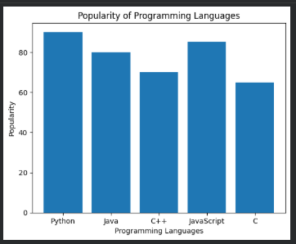
28. Horizontal Bar Chart of Programming Languages
import matplotlib.pyplot as plt
languages = ['Python', 'Java', 'C++', 'JavaScript', 'C']
popularity = [90, 80, 70, 85, 65]
plt.barh(languages, popularity)
plt.xlabel("Popularity")
plt.ylabel("Programming Languages")
plt.title("Popularity of Programming Languages")
plt.show()
OUTPUT:
